Classic Member Events Heat Up
This Month at Hualalai Resort

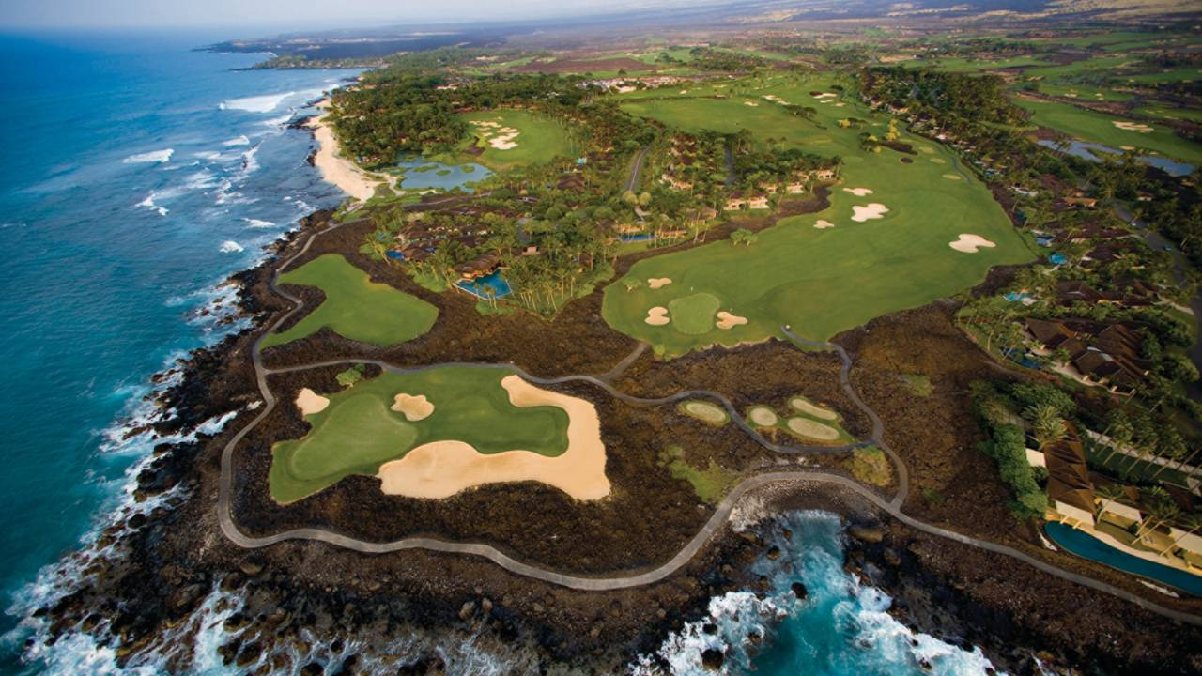

The member only event, now in its 15th year, takes place the first Friday in August annually and is one of many events hosted throughout the year.

One of the many benefits of home ownership at Hualalai Resort on Hawaii Island’s in-demand Kona Coast are community building annual special events designed exclusively for Hualalai Club members. Membership in the club is reserved exclusively for property owners at this exclusive luxury residential resort.
On Friday, August 3, the Annual Canoe Club Regatta takes place on beautiful Uleweuweu Bay fronting the resort’s southern flank. Originally featuring a series of six-person outrigger canoe races with members and junior members making up the teams, a 100 yard stand up paddle course recently has been added to the mix.
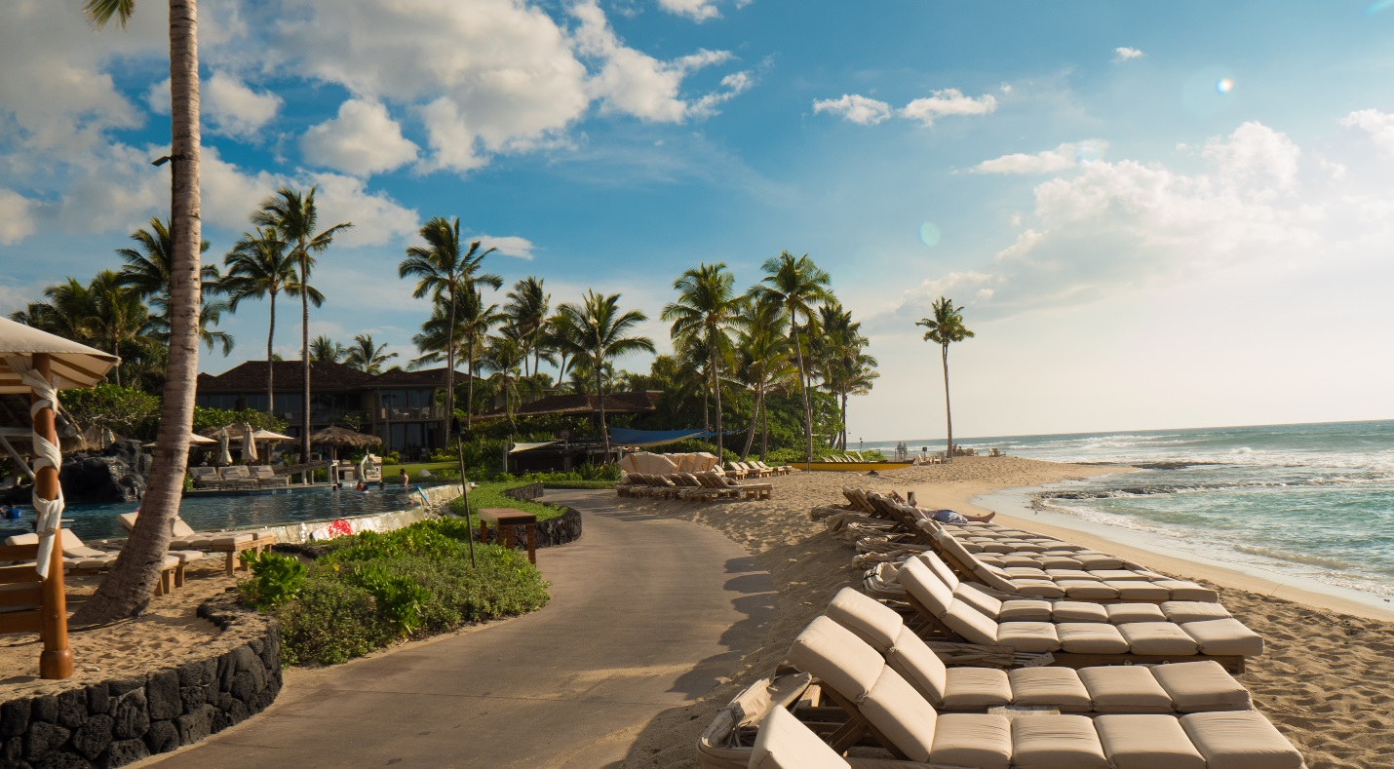

Stand up paddling is now part of the regatta fun.

An awards lunch follows the morning action at the Hualalai Canoe Club, a popular member-only amenity.
On Tuesday, August 7, the action shifts up mauka (towards the mountains) to the member-only Ke’olu Clubhouse for the final “Hot Hawaiian Nights” musical event of the summer. The award-winning trio, Na Hoku, headline this dinner and a show for the entire family.
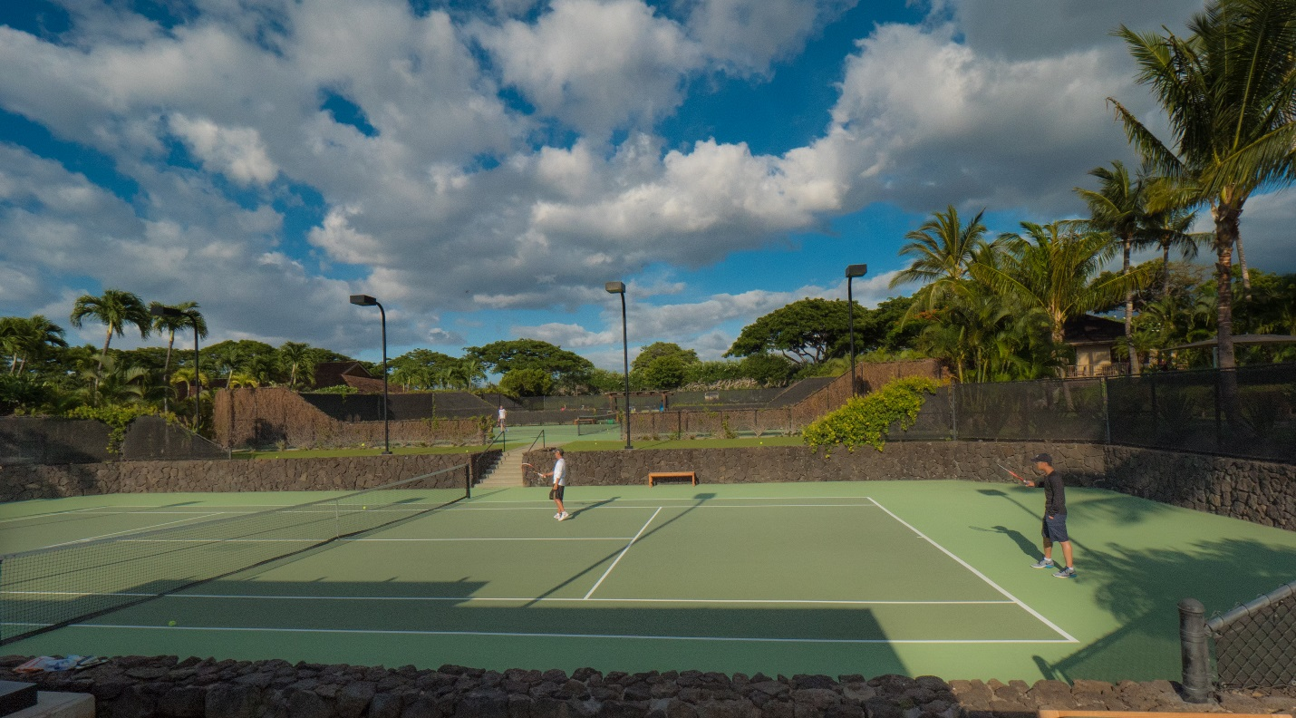
Members take to the courts on Wednesday, August 15 for the summer round robin knockout-style tennis tournament. Hosted by the club’s tennis professionals, this friendly and spirited competition includes complimentary beverages and snacks.
Artist workshops, cooking demonstrations, themed dinners and night glow golf are among the many additional member summer activities.
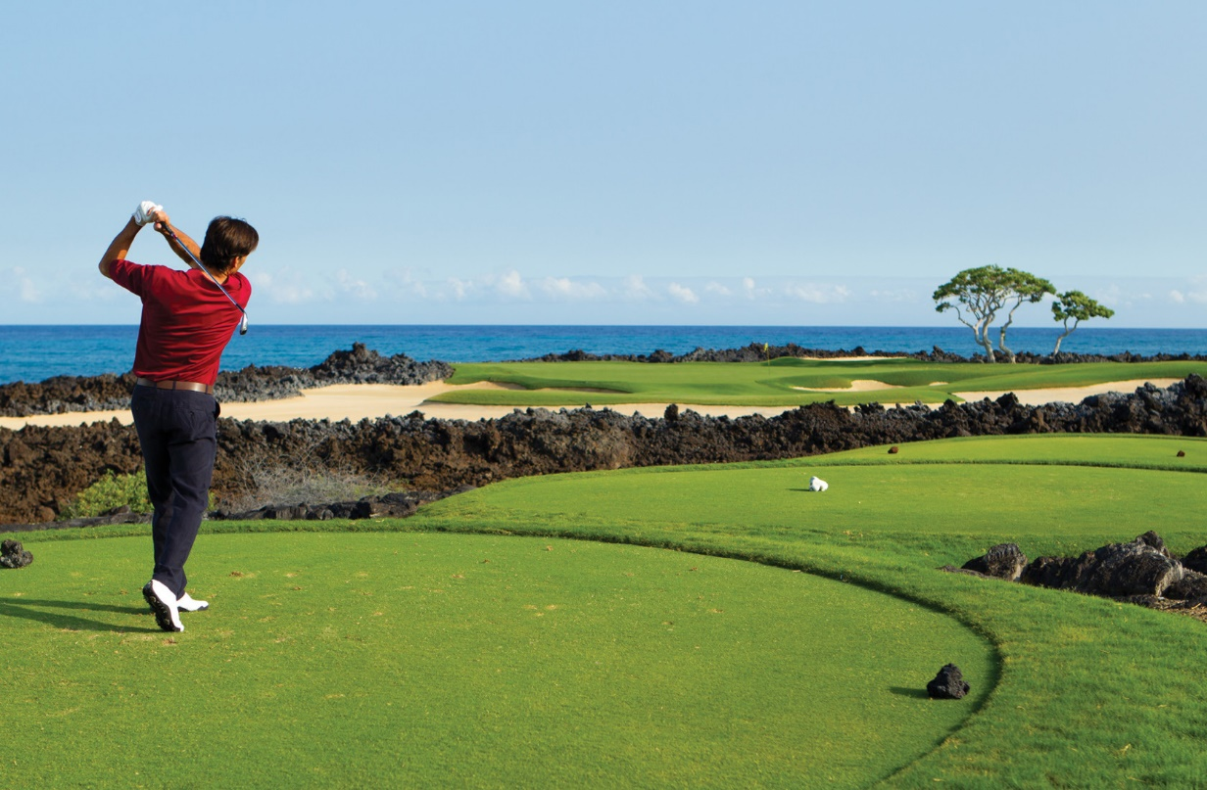
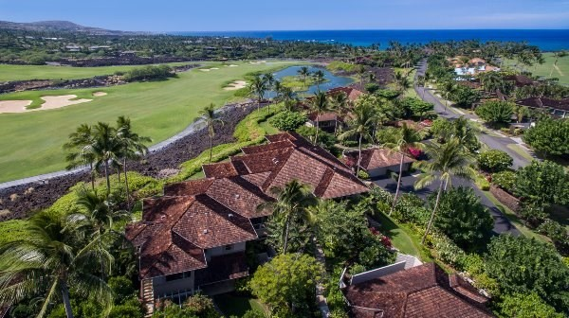
Villas, estate villas, single-family homes and custom home sites form the luxury real estate opportunities at Hualalai Resort – both new construction and re-sales.
More Information

For information about properties at Hualalai Resort or additional Hawaii Island real estate opportunities, please contact Carrie Nicholson, R (B), BIC, Director of HL1-Big Island, (808) 896-9749 or carrie@HL1.com.

